Chapter 1:

User Tasks

In this section we will cover the basic tasks that users perform:

* Register for an account
* Request group access
* Reset a lost password
* Update account information
* Run/Launch an experiment
* Request help

# Register for an account

Registering for an iLab account gives users access to the experiments in their group.

1. Using any standard web browser connected to the internet and type in the URL of your local Service Broker. We recommend using Microsoft Internet Explorer version 7 or greater.
2. On the iLab home page, scroll down towards the bottom of the page and click on the "register here" link.

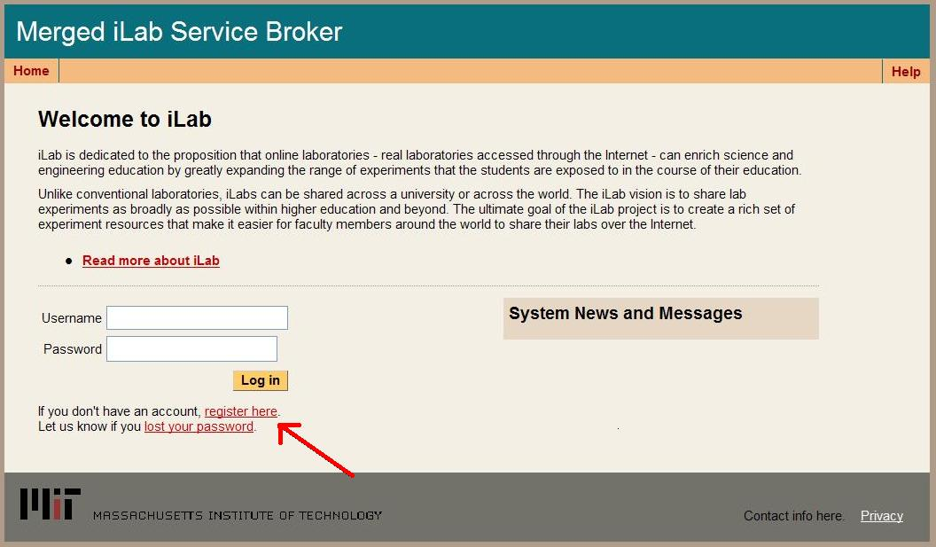

1. Enter your information into the registration form. If you are part of a group or class, please remember to select the group name from the "Requested Group" pull down list.

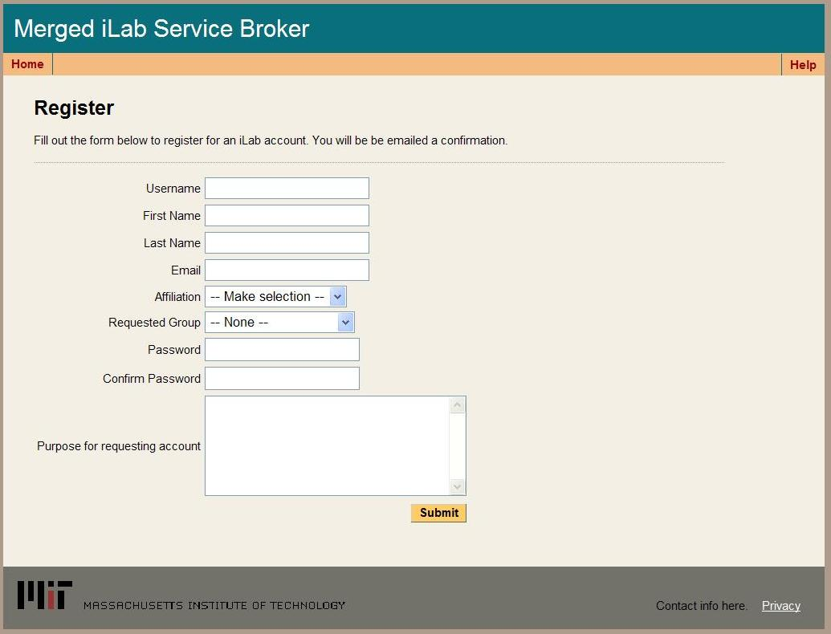

|  |  |
| --- | --- |
| **Field Name** | **Field Description** |
| Username | Users can pick their own user name using any UTF-16 characters. |
|  |  |
|  |  |
| First Name | User’s first name |
| Last Name | User’s last name |
| E-mail | User’s e-mail address. It is important that a valid e-mail is associated with each user account. |
| Affiliation | Choose the appropriate description, choices include Student, Staff/Faculty, Guest, and Other; If the users chooses other, they should explain in the comment field "Purposes for requesting account". |
| Requested Group | This drop down list contains the list of groups that can be requested. Users who want to request multiple groups can do so once their account has been created. |
| Password | User’s password. User password cannot be recovered. There is an automated utility for resetting a user’s password and emailing it to the email address associated with the account. |
| Purpose for requesting account | This field is optional. Users can type their purposes for creating account or any other comments. |

1. Click on the Submit button at the bottom of the form when you have finished entering your information.
2. You will receive an email when your account has been activated. Please be patient, account activation can take between 24-48 hours.

# Request group access

Sometimes iLab users will need access to more than one experiment group. There is no reason to create a separate account for each class. Users just need to request access to a new group.

1. Use any standard web browser connected to the internet and type in the URL of your local Service Broker.
2. From the iLab home page log in to your account.
3. Once logged in, select the My Account tab from the main menu.

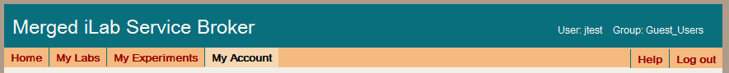

1. On the My Accounts page, select the “Request membership in a new group” link on the right side.

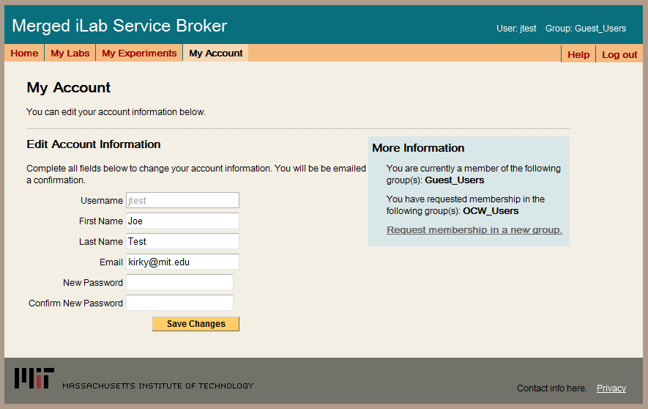

1. Select the new group(s) from the list of available groups on the left side and click on the Request Membership button.

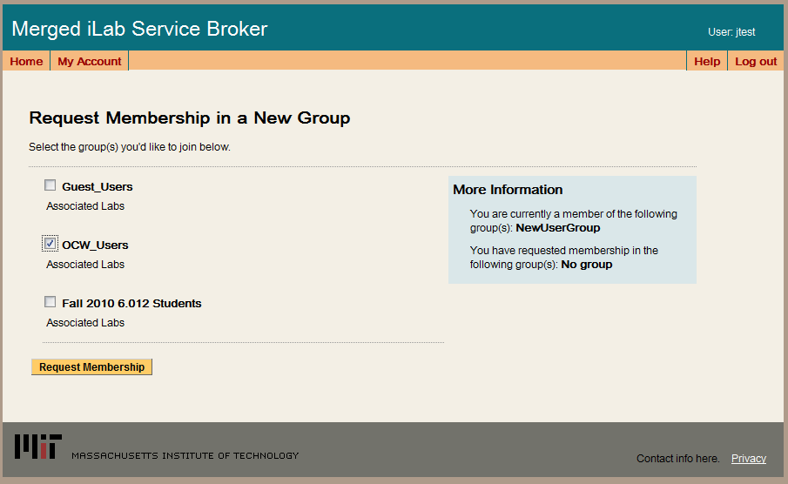

1. You will see the group(s) you have requested membership listed on the right side.

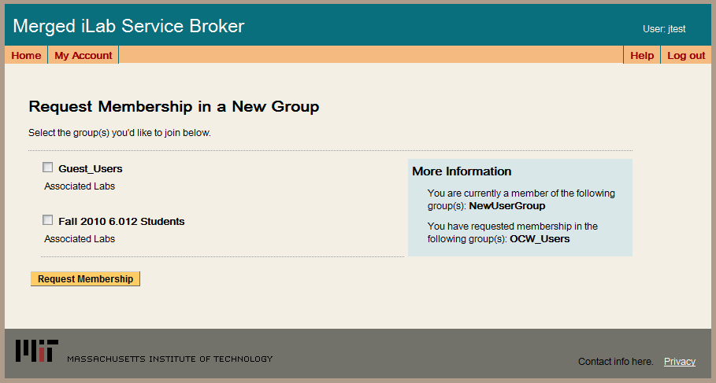

1. Your request will be sent to the administrator for approval. Approvals can take 24-48 hours to process.

# Reset a lost password

Occasionally users will forget their password and need it to be reset.

1. Using any standard browser connected to the internet, type in the URL of your local Service Broker. Click on the lost your password link.

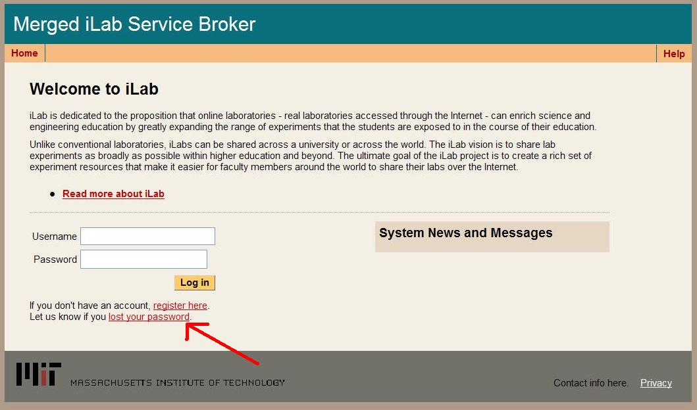

1. Enter your iLab username and email address. Please note that the entered email address must match the email address in the iLabs database.

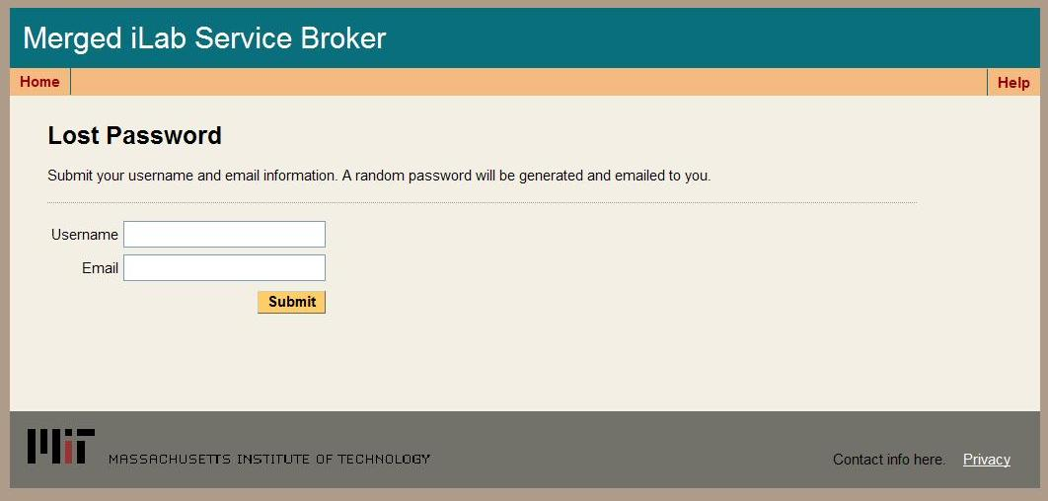

1. Click on the Submit button at the bottom of the form when you have finished entering your information.
2. You will receive an email with a new password.

# Update account information

Periodically, users need to update their personal information or email address. This can be done from the My Accounts tab.

1. Use any standard web browser connected to the internet and type in the URL of your local Service Broker.
2. From the iLab home page log in to your account.
3. Once logged in, select the My Account tab from the main menu.



1. On the My Accounts page, update your information. Please note that usernames can not be changed.



1. Click on the Save Changes button when you have finished updating your information.

# Run/Launch an experiment

1. Using any standard browser connected to the internet, login to your local Service Broker.
2. If you are part of several groups, you will automatically be directed to the My Groups page. Please note that if you are only part of one group, you will not see the My Groups page.
3. Click on a group link to select the group.

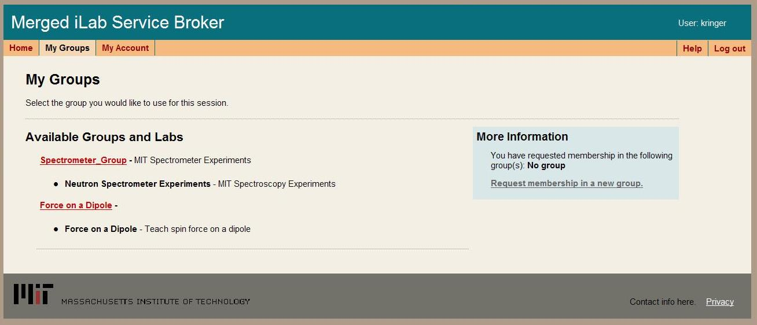

1. If the experiment does not require scheduling, you are ready to launch the experiment. Click on the Launch button to run the experiment client.

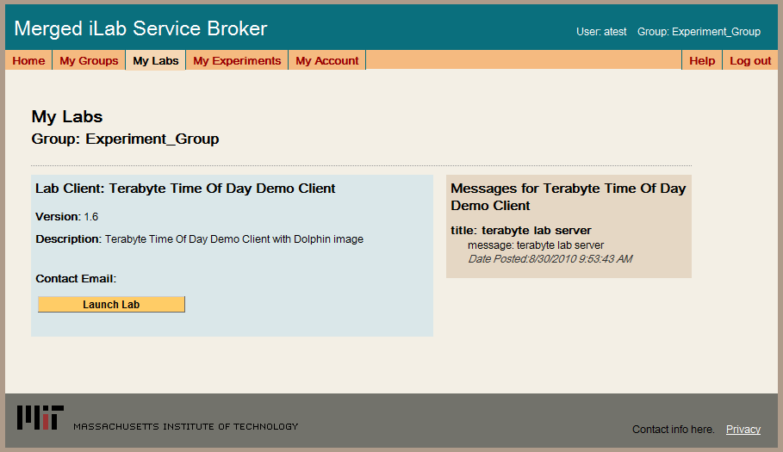

1. If the experiment requires scheduling, you will see a Schedule/Redeem Session button. Click on the Schedule/Redeem Session button.

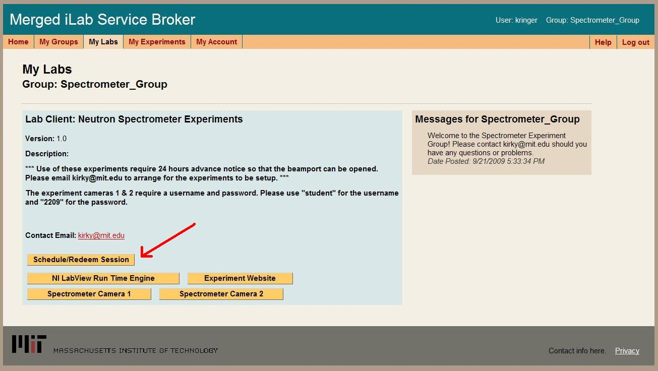

1. On the Scheduling Server, select the reservation for the current time slot.

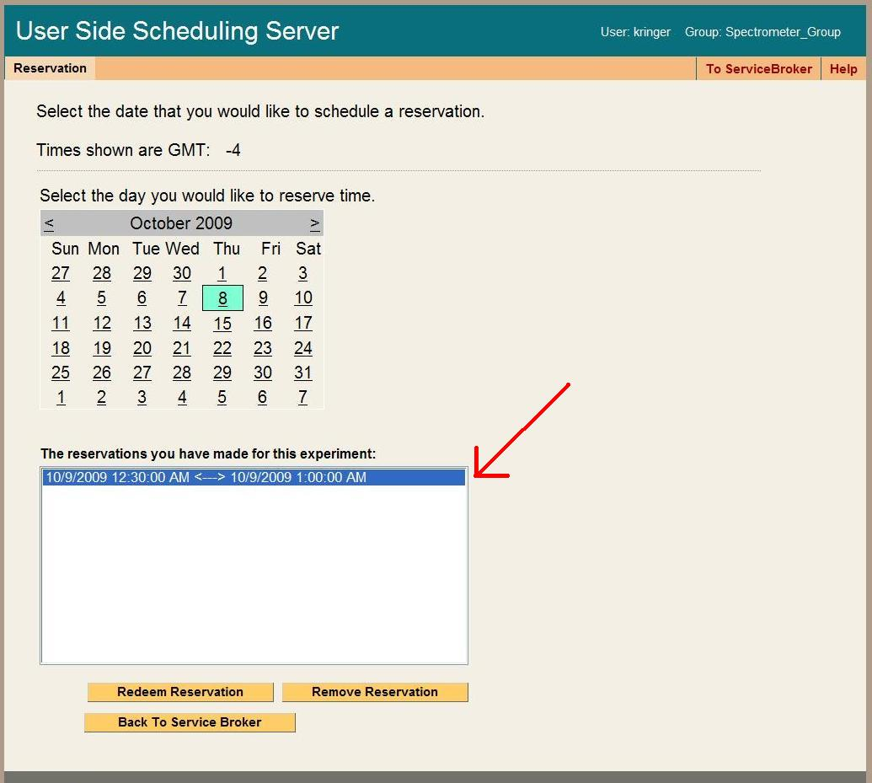

1. Click on the Redeem Reservation button to begin.

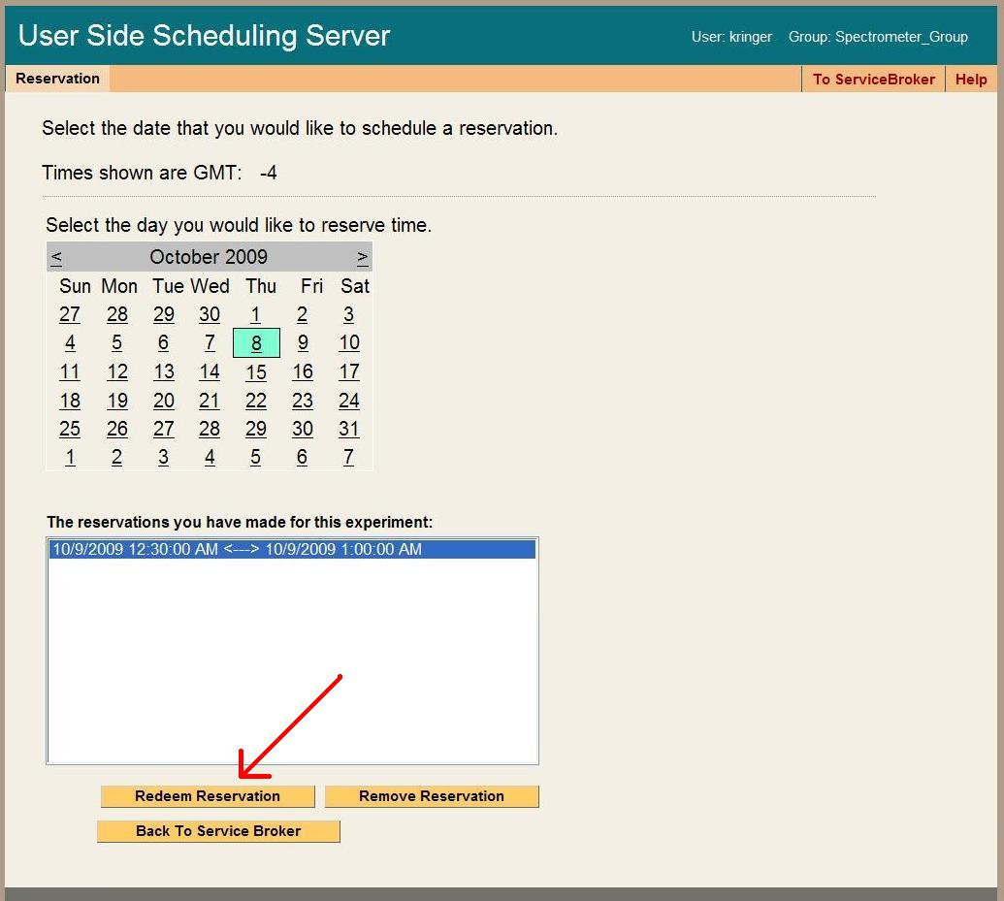

1. Back on the My Labs page, you will now have a Launch button. Click on the Launch button to run the experiment client.

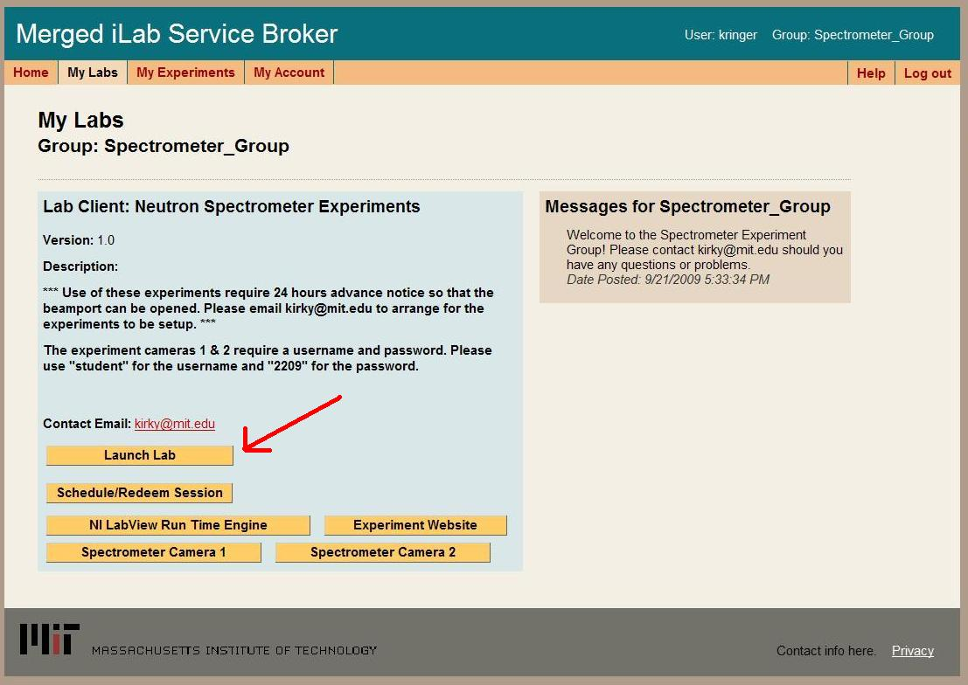

# Retrieve experiment results

1. Using any browser connected to the internet, login to your local Service Broker.
2. Click on the "My Experiments" tab in the main menu.



1. In the Search Experiments form in the left hand column, use the scroll bar to select an experiment based on the date and time it was run.

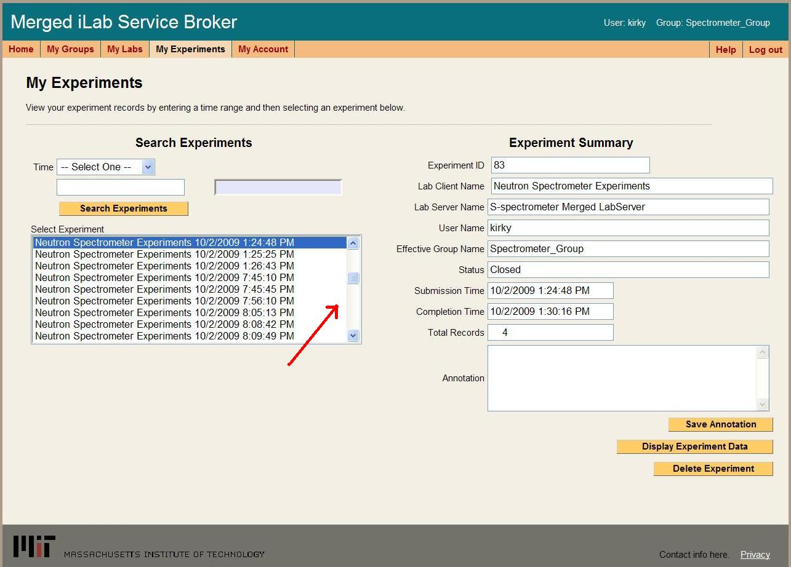

1. Once an experiment has been selected, the Experiment Summary form in the right column, will be automatically populated.
2. Click on the Display Experiment Data button.

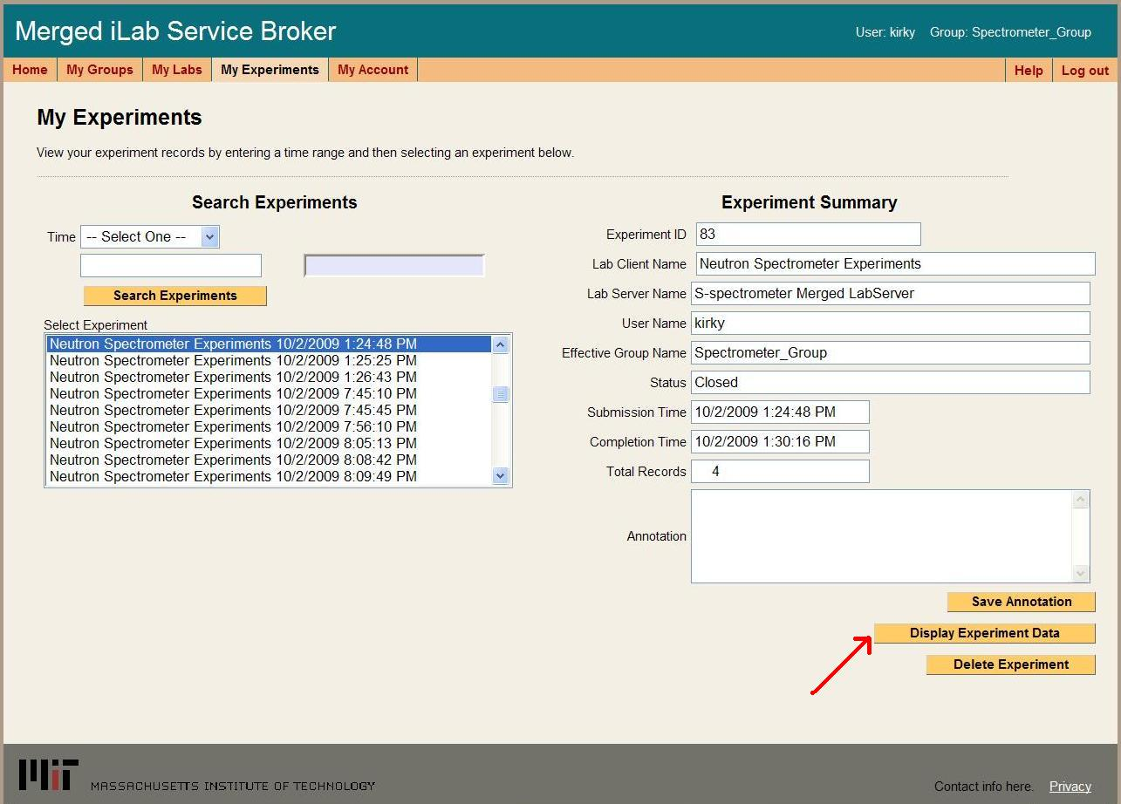

1. In the Show Experiment page, click on the Get Records button to retrieve all the records about this experiment in a table format.

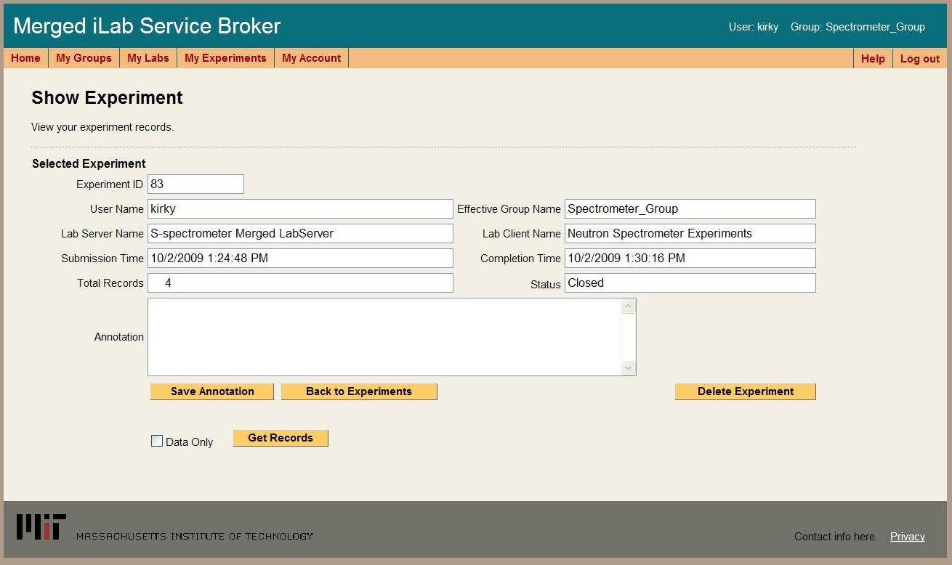

1. Records are shown is a table format for easier reading.

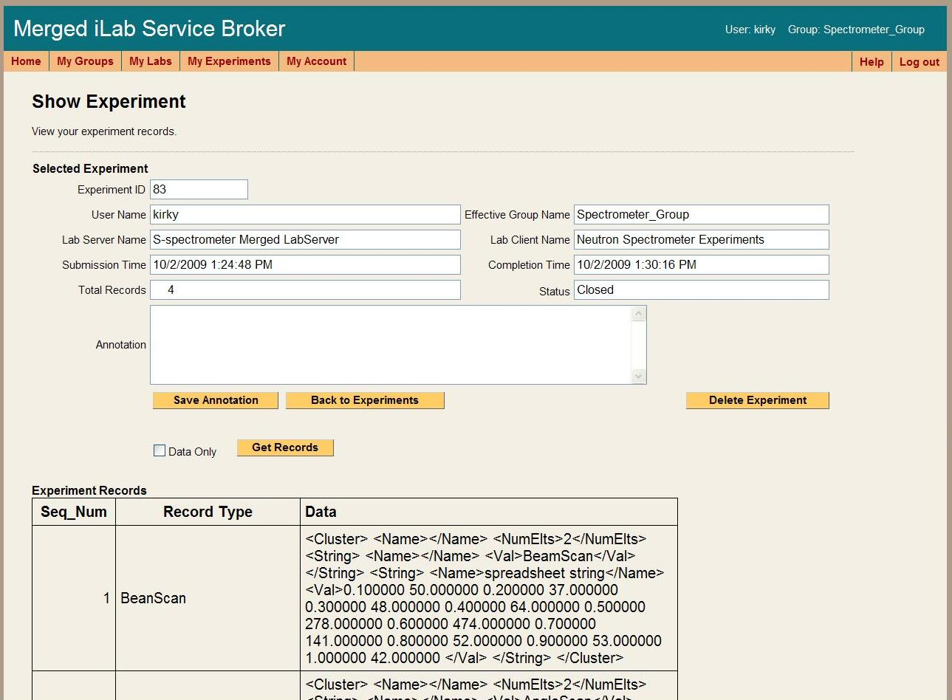

1. From the Show Experiment page, you can also display the data only records in a XML format that can be cut and pasted into another application. Click in the box next to Data Only to select it.

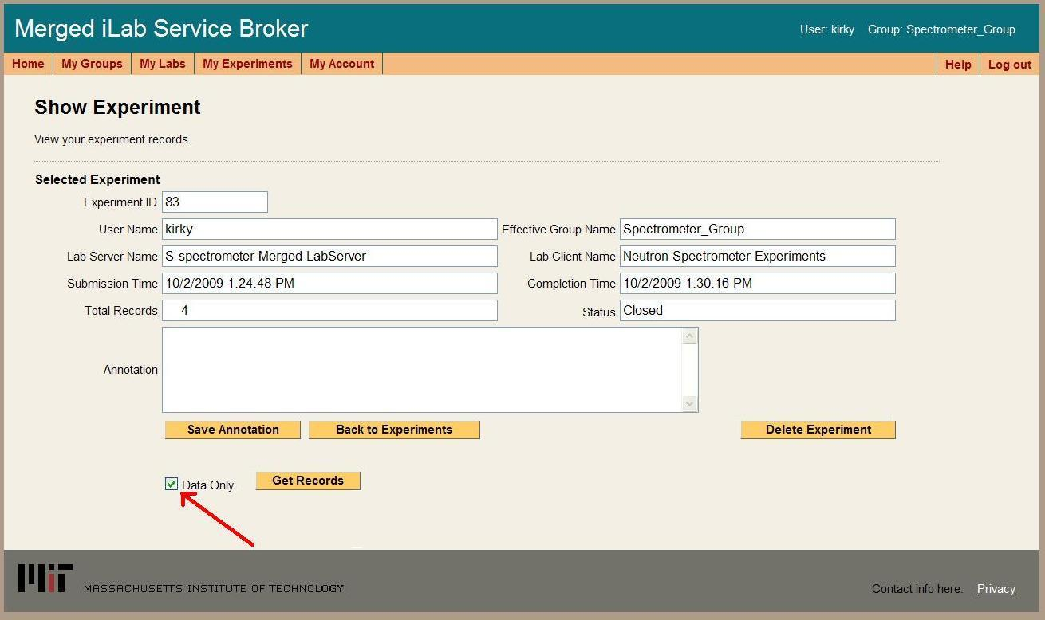

1. Click on the Get Records button to retrieve only the data records in a XML format.

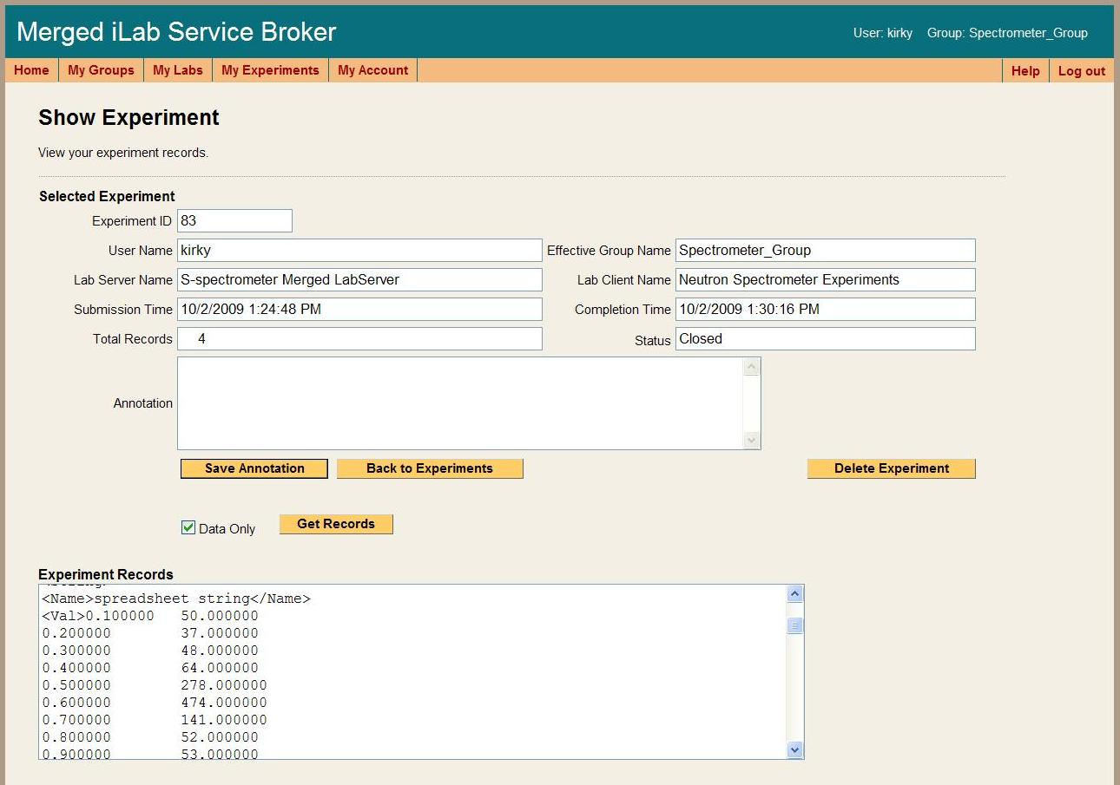

# Request help

1. Using any browser connected to the internet, login to your local Service Broker.
2. Click on the "Help" tab in the main menu.

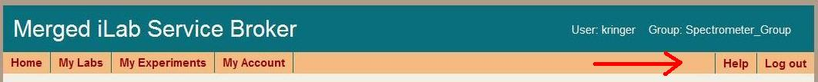

1. From the Help page, click on the Request Help link.

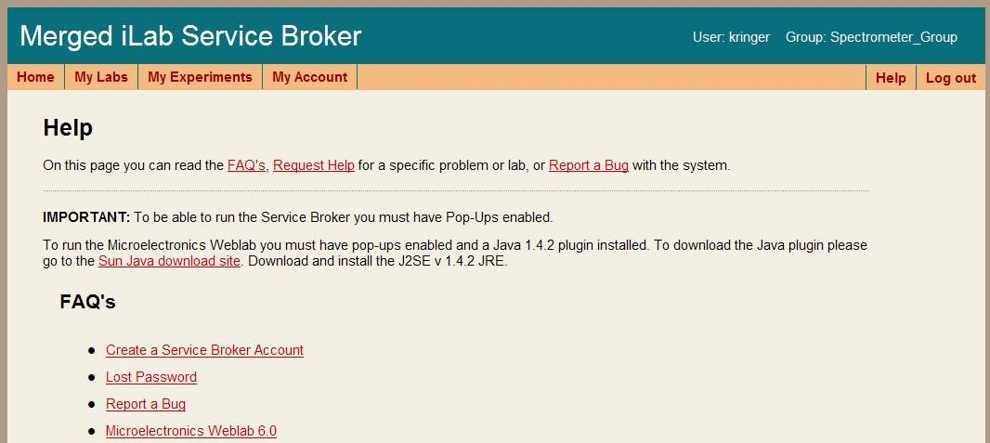

1. Please use the pull down list to select the type of help you need or the issue you are having.
2. Use the textbox to describe the problem in detail. Please include the operating system and browser you are using.

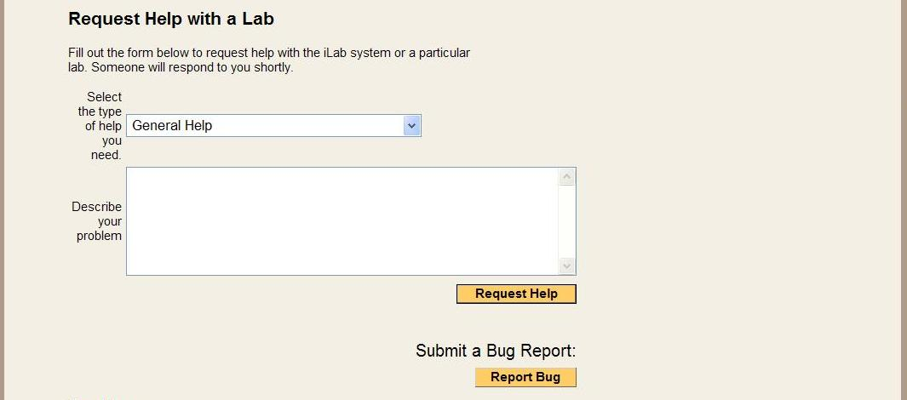

1. When finished, click on the Request Help button to submit the report.

How do administrators ...

Create a user account

Delete a user account

Disable a user account

Create a user group

Create an administration group

Edit group information

Add users to a group

Remove ussers from a group

Search for users

Create new messages

Delete messages

Retrieve experiment results

Retrieve login records

Run Group Reports

Retieve user session information

How do you manage experiment scheduling

Retireve schedule reservations

Revoke scheduled reservations

Understanding Passthrough Options

Understanding loaderscript variables

Quick Reference Guides